**ERD for Inventory Management System**

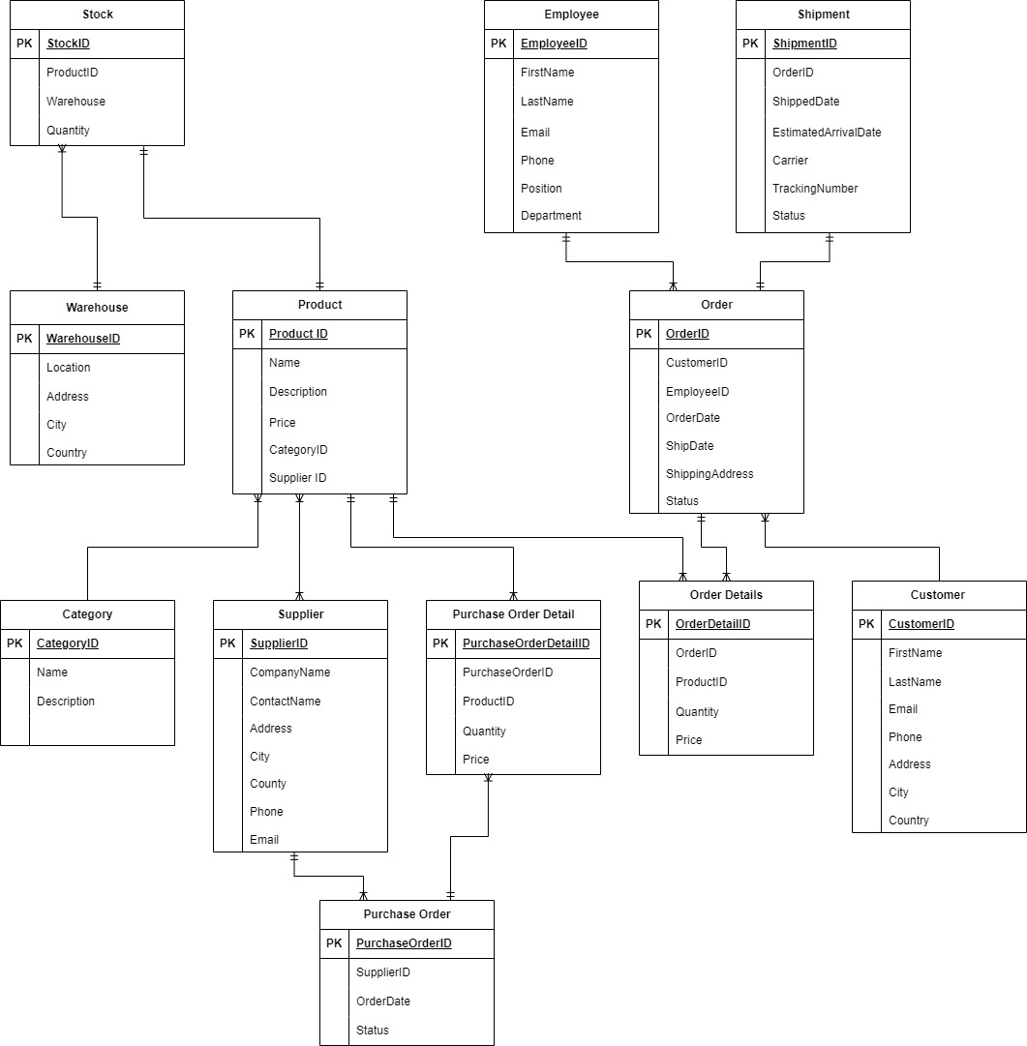

The ERD outlines an Inventory Management system. Products are categorized and supplied by multiple suppliers. Customers place orders containing specific products. Stock records track product quantities in warehouses. Employees process orders, leading to shipments for delivery. Purchase orders are placed to restock inventory. The system focuses on inventory optimization, order efficiency, supplier management, and sales tracking. Privacy and security measures safeguard customer and employee data.

**Entities:**

1. **Product** - Represents the items in the inventory.

2. **Category** - Represents the categories or types of products.

3. **Supplier** - Companies or individuals who provide the products.

4. **Customer** - End users or businesses purchasing the products.

5. **Order** - Transactions involving the purchase of products by customers.

6. **OrderDetail** - Specific items and quantities within an order.

7. **Stock** - Represents the quantity of each product available in the inventory.

8. **Warehouse** - Physical locations where inventory is stored.

9. **Employee** - Staff involved in managing inventory, processing orders, etc.

10. **Shipment** - Details of the product dispatch from the warehouse to customers.

11. **PurchaseOrder** - Transactions involving the restocking of products from suppliers.

12. **PurchaseOrderDetail** - Specific items and quantities within a purchase order.

**Relationships:**

**Product - Category:** (Many-to-One)

Each Product belongs to one Category, and each Category can include many Products.

**Product - Supplier:** (Many-to-Many)

Each Product can be supplied by multiple Suppliers, and each Supplier can supply many Products.

**Product - OrderDetail:** (Many-to-One)

Each OrderDetail refers to one Product, and each Product can be part of many OrderDetails.

**Order - OrderDetail:** (One-to-Many)

Each Order can contain many OrderDetails, and each OrderDetail is part of one Order.

**Order - Customer:** (One-to-Many)

Each Order is placed by one Customer, and each Customer can place many Orders.

**Product - Stock:** (One-to-One)

Each Product has one Stock record, and each Stock record refers to one Product.

**Stock - Warehouse:** (One-to-Many)

Each Stock record is associated with one Warehouse, and each Warehouse can house many Stock records.

**Employee - Order:** (One-to-Many)

Each Order is processed by one Employee, and each Employee can process many Orders.

**Shipment - Order:** (One-to-One)

Each Shipment delivers the products of one Order, and each Order can result in one Shipment.

**Product - PurchaseOrderDetail:** (Many-to-One)

Each PurchaseOrderDetail refers to one Product, and each Product can be part of many PurchaseOrderDetails.

**PurchaseOrder - PurchaseOrderDetail:** (One-to-Many)

Each PurchaseOrder can contain many PurchaseOrderDetails, and each PurchaseOrderDetail is part of one PurchaseOrder.

**Supplier - PurchaseOrder:** (One-to-Many)

Each PurchaseOrder is placed with one Supplier, and each Supplier can receive many PurchaseOrders.

**Business Problems Addressed**

The Inventory Management database aims to address several key business problems:

**Inventory Optimization:** Ensuring optimal product quantities to meet customer demand while avoiding overstocking.

**Order Processing Efficiency:** Improving customer satisfaction by streamlining the order placement, processing, and fulfilment processes.

**Supplier Management:** Effectively managing relationships with multiple suppliers to ensure timely restocking of products.

**Warehouse Management:** Optimizing warehouse space and inventory locations to minimize retrieval times and costs efficiently.

**Sales Tracking and Forecasting:** Utilizing sales data tracking to forecast future demand and adapt inventory levels accordingly.

**Key Database Design Decisions**

**Normalization:** Entities are structured to maintain data integrity and minimize redundancy. For instance, the segregation of OrderDetail from Order enables the independent management of each order's line items.

**Entity Relationships:** Thoughtful consideration of cardinalities guarantees a precise portrayal of real-world connections, like products being provided by several suppliers and orders comprising multiple products.

**Scalability:** The design is flexible to accommodate future growth, including the potential addition of new entities for managing returns, exchanges, or advanced inventory forecasting.

**Security and Privacy:** Customer and Employee data are regarded as sensitive, with relationships structured to enable access controls and ensure privacy protection.

**Project Scope:**

The project involves developing a comprehensive Inventory Management system with key components to facilitate efficient business operations. This includes establishing a centralized database to manage product details, supplier information, customer orders, and inventory levels securely.

To enhance user experience, the system will integrate with secure payment gateways for seamless transactions. It will provide real-time updates on product availability, order statuses, and inventory levels to both customers and employees, facilitating informed decision-making.

The project aims to optimize inventory levels, streamline order processing, and improve supplier management. It will feature functionalities such as stock tracking, order fulfillment, and purchase order management to ensure efficient inventory handling.

Additionally, the system will prioritize scalability and flexibility to accommodate future expansion and changing business needs. It will be designed for easy integration of new functionalities or modifications as required.

Overall, the project aims to deliver a robust Inventory Management system that addresses key business challenges while providing a user-friendly interface and ensuring data security.